Hello!
It was such a pleasure getting to see you and your child at your last study visit! Thank you so much for choosing to participate in the home language recording. We appreciate your participation and continued support of our research! As promised, we would like to provide you with a snapshot of the results. Below you will be able to see a snapshot of your child’s language skills as well as a look at the audio environment in your home from the day of your recording. If you have any questions or concerns about your child’s language development, please feel free to share these results with your family doctor or pediatrician. You are also always more than welcome to contact the NEED lab (needlab@tc.columbia.edu, 917-740-4123) with any questions or concerns regarding this information.
We hope that this information is useful to you, and we thank you once again for continuing to support our study!
Best,
The NEED Lab Research Team
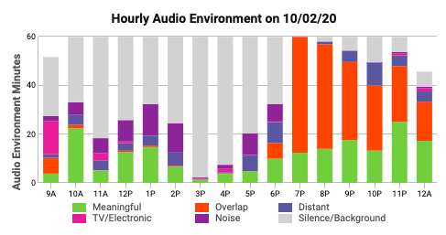

What is this? This is an automated, hourly breakdown of the types of sounds that your LENA device recorded in your home throughout the day you recorded. For every hour that the LENA was recording, this graph shows you how many minutes are represented by different kinds of noise. While, on average, the automated LENA software is good at estimating what sounds were recording, it isn’t perfect. Please do not worry if these data look a little different than you expected.
What does this mean? Below are some terms that will help you understand the different types of audio information that LENA device was able to identify:
Meaningful – this is sound in the home environment that has meaning to it, such as words or conversations
TV/Electronic – this is noise coming from an electronic device such as a television or an Ipad
Overlap – this is anytime there were overlapping sources of audio noise. For example, if the TV was playing while someone was having a conversation, this would be considered overlap because there were two sources of audio happening at the same time
Noise – this is general noise happening in the environment, such as horns honking, sirens, or music playing outside of the home
Distant – this is noise in the far background of the recording that cannot be fully understood, such as faint noises outside of the home, or if people are talking several rooms away from where the LENA device is located
Silence/background – this is when there is little to no noise in the environment. This may also be when your child is napping or sleeping.

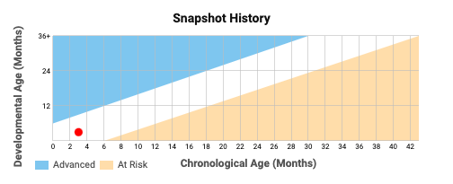

What is this? The snapshot shows how your child’s language skills are developing. Chronological age is your child’s current age in months. Developmental age is LENA’s estimate of your child’s age based on their language skills. If your child’s language skills are typical for a child their age, then their developmental and chronological age will be nearly equal. If their skills are advanced, their developmental age will be higher than the chronological age, and if their skills are at risk, their developmental age will be lower than their chronological age.
What does this mean? These results came from your answers to the questions asked on the LENA Snapshot survey. These questions asked you about your observations of your child’s vocalizations, expressive cues, and language skills. Based on these results, the snapshot history reflects whether your child’s language skills are typical, advanced, or at risk for their chronological age.
Please note: if your child falls into the “at risk” range, this does not mean that you have reason to be worried about their language development. Every child develops at a different pace for a variety of reasons. These results were based on survey questions alone as opposed to a professional evaluation, which provides a limited view of child’s language abilities, especially this early in a child’s life. If you are concerned about your child’s development, please feel free to share this with your pediatrician, family doctor, or administrators at your local WIC clinic. They will be able to interpret these results within the context of your child’s medical and developmental history, as well as give you recommendations. You may also contact us at the lab (needlab@tc.columbia.edu, 917-740-4123) if you have further questions or if would like to share any comments or concerns.

